Ambient Systems

Business Plan

Prepared by:
Ivan Damnjanović
Founder & CEO

Date: November 13, 2023


Prepared Exclusively for: Hong Kong Science & Technology Park

Executive Summary

Introduction
Ambient Systems is a visionary technology company at the forefront of transforming financial operations through cutting-edge Financial Planning and Management Software (FP&M SW). Our mission is to redefine financial management for businesses by seamlessly integrating innovative new technology, such as AI and IoT, into a comprehensive platform that empowers finance executives and their teams to make informed, data-driven decisions.
Mission, Vision & Values:
Mission: Ambient Systems is committed to pushing the boundaries of financial technology, unlocking new possibilities for finance teams through advanced software solutions. We strive to streamline financial operations, enhance decision-making, and drive efficiency in the digital age.
Vision: Our vision is a future where financial management is synonymous with innovation, where businesses thrive with the aid of technology, making strategic decisions that propel them toward success.
Values: Ambient Systems values Innovation, Value Creation, Efficiency, and Expertise. We pioneer cutting-edge solutions, deliver tangible value to clients, streamline processes for maximum efficiency, and apply deep tech expertise to advance financial performance.
Strategic Objectives:
- Innovative Solutions: We aim to develop and deliver ground-breaking FP&M SW that surpasses traditional solutions, incorporating AI and IoT for unparalleled efficiency.
- Market Leadership: We aim establish market leadership in sustainable infrastructure and food industries, including Commercial Real Estate, Vertical Farming, and Transportation, leveraging our technical expertise and industry partnerships.
- Global Expansion: We plan to position Ambient Systems as a key player in the global financial management software market, starting with strategic entry points in Hong Kong, GBA, and China.
With the partnership with HKSTP, Ambient Systems is poised for growth, guided by an experienced visionary team, cutting-edge technology, and a commitment to redefining financial management in the digital age. Our unique solutions and strategic roadmap position us as a key player in the evolving landscape of financial technology.

Section 1: Products & Solutions to Be Developed

Concept, Features, and Application
Ambient Systems envisions the development of a cutting-edge Financial Planning and Management Software (FP&M SW) designed to revolutionize financial operations and enhance financial performance of businesses. This cloud-based solution integrates innovative technologies, including artificial intelligence (AI) and the Internet of Things (IoT), to provide a comprehensive suite of features.

Features:
- Comprehensive Financial Management: Streamlines financial tasks by consolidating data from various sources.
- Integration of IoT and Data Collection: Enhances accuracy by incorporating IoT for real-time operational data (particularly valuable for the customers in sustainable infrastructure industry, such as transportation and commercial real estate)
- Unified Platform: Addresses diverse financial challenges, such as revenue forecasting, tax management, and risk assessment.
- AI-Driven Recommendations: Empowers decision-making through AI-generated insights.
- Data Accuracy and Compliance: Ensures accuracy and compliance by leveraging AI for verification and anomaly identification.
- Enhanced Decision-Making: Facilitates improved decision-making and profitability through comprehensive financial tools.

Application: Ambient Systems' FP&M SW caters to finance teams across industry verticals, including Commercial Real Estate, Transportation, Vertical Farming, Construction, Facility Management, and Financial Services. This software provides a unified platform for financial planning, reporting, and analysis, offering actionable insights to drive financial performance.

Problems to Resolve
Ambient Systems aims to address several challenges prevalent in traditional financial management methods:
- Manual Processes: Elimination of time-consuming manual processes and spreadsheet-based data management and analysis.
- Limited Data Integration: Overcoming the lack of integration with IoT and data collection systems in existing financial software.
- Fragmented Financial Operations: Providing a unified platform to tackle disjointed processes in traditional solutions.
- Lack of AI Capabilities: Filling the gap in conventional solutions by incorporating AI-driven recommendations.
- Data Inaccuracies and Compliance Issues: Ensuring data accuracy and compliance by leveraging AI for verification and anomaly identification.

Technology Employed and Why It is Better
Ambient Systems utilizes a powerful combination of cloud computing, AI, and IoT technologies to outperform traditional financial management solutions:
- Seamless Integration: Cloud-based architecture ensures seamless integration with ERP, CRM, and accounting systems.
- Real-time Operational Data: IoT integration provides accurate and up-to-date operational data, enhancing financial forecasts.
- AI-Driven Insights: AI algorithms generate informed recommendations, improving decision-making in various financial aspects.
- Data Verification and Anomaly Identification: AI is employed to verify datasets and identify anomalies, ensuring data accuracy and compliance.
- Cloud-based Platform: high-performance computing available through a distributed network of devices and systems provide unparallel performance advantages.

Technology Niche and Technical Challenges
Technology Niche: Ambient Systems occupies a unique niche by combining AI, IoT, and cloud computing to provide a holistic financial planning and management solution. This comprehensive approach sets it apart from traditional solutions lacking integration and AI capabilities.

Technical Challenges:
- Data Security: Ensuring the security of sensitive financial data in a cloud-based environment.
- IoT Integration: Overcoming challenges related to the integration of diverse IoT devices and data streams.
- AI Optimization: Continuous optimization of AI algorithms for more accurate predictions and recommendations.
- User Adoption: Addressing potential challenges related to user adoption of advanced technologies in financial management.

Illustrations: Ambient Systems Platform

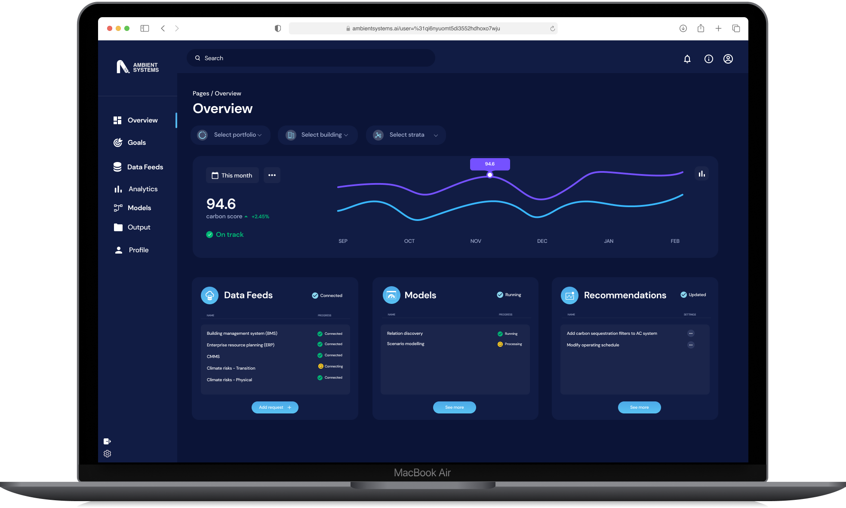
Please refer to the attached image for visual representations of Ambient Systems' FP&M SW architecture, IoT integration, and AI-driven decision-making. Additional diagrams can be found in the Appendix D: Product.
Adaptive. Accurate. Affordable.
- Comprehensive Financial Planning & Management Software (FP&M).
- Integration of IoT and Data Collection.
- Addresses Multiple Financial Challenges with Optimized AI Algorithms.

The product roadmap is also included in Appendix C: Product Roadmap for reference.

Section 2: Research and Development (R&D) Content and Plan

Current Status of Development
Ambient Systems has already achieved significant progress in its product development and R&D activities. Ambient Systems is actively engaged in the research and development phase, with a focus on understanding and addressing the diverse needs of enterprise customers in financial management. The company has identified seven crucial categories of customer needs and is in the process of developing a feature-rich Financial Planning and Management Software (FP&M SW) to meet these requirements.

What Has Been Done? What Will Be Done?

- Customer Insights Gathering:
  - Conducted extensive customer interviews to understand pain points and requirements.
  - Conducted thorough market research and competitor analysis to identify industry gaps.
- Feature Identification and Prioritization:
  - Identified 15 key features crucial for addressing diverse financial challenges.
  - Prioritized features into Essential, Must-Have, and Could-Have categories based on customer pain points.
  - Developed most of the essential features and deployed on the cloud.
- Use Case Definition:
  - Defined use cases for Ambient Systems across finance activities and industry verticals.
  - Categorized use cases into Finance (e.g., Decarbonization Reporting, Valuation) and Industry Verticals (e.g., Commercial Real Estate, Transportation).
- Vertical Farming POC:
  - Developed a successful proof-of-concept for vertical farming in Singapore, incorporating sensing hardware.
  - Secured an exclusive patent license with the National University of Singapore.
- Decarbonization Reporting:
  - Won first runner-up at a Google Cloud hackathon in Singapore for our innovative approach to decarbonization reporting in the commercial real estate sector.
- Panasonic Deep Tech Innovation Challenge:
  - Emerged as the winner, paving the way for a collaboration to leverage Panasonic's wireless technology for enhanced data collection in the transportation industry.

What will be done:
- Feature Refinement:
  - Refine and finalize features based on potential changes in customer prioritization.
  - Iterate on features to enhance usability and effectiveness.
- Development and Integration:
  - Initiate the development and integration of Essential features.
  - Progress to incorporate Must-Have features and commence initial testing.
- Industry Partnerships:
  - Strengthen collaborations with industry leaders to gather real-world insights, ensuring our solutions align with evolving market needs.
- Market-Specific Features:
  - Develop industry-specific features, building on our success in vertical farming and transportation to cater to the unique challenges of each sector.

R&D Development Schedule

- Year 1: Focus on foundational development, further proof-of-concept deployment (in-lab and on-the-field), and refining core features of the FP&M SW.
- Year 2: Expand functionalities based on market feedback, initiate collaborations, and conduct feasibility studies for global expansion.
- Year 3: Roll out advanced features, solidify global partnerships, and explore new avenues for innovation and market penetration.

Core Invention or Innovation Out of R&D Activities

The core innovation stemming from our R&D activities is the development of a comprehensive FP&M SW that seamlessly integrates AI and IoT technologies. This software addresses critical challenges faced by finance teams by providing:

- Accurate Financial Forecasting: Leveraging AI to consolidate financial and operational data, offering precise forecasts for revenue and expenses.
- IoT Integration: Incorporating IoT and data collection for real-time operational insights, enhancing the accuracy of financial predictions.
- Unified Financial Management: Providing a holistic platform that addresses various financial challenges, from revenue/expense forecasting to risk management, ensuring streamlined financial operations.
- AI-Driven Recommendations: Utilizing AI algorithms to offer actionable recommendations for informed decision-making, ranging from forecasting to cost reduction.
- Data Accuracy and Compliance: Ensuring data accuracy and compliance by leveraging AI to consolidate, verify, and identify anomalies in datasets, extending compliance checks to operational data through IoT.

While specific patents are pending, these innovations contribute to Ambient Systems' intellectual property portfolio, and the company anticipates filing patents to safeguard key technological advancements upon completion of the filing process and relevant approvals.

Section 3: Sales and Marketing Plan
Target Customers and End-Users
Target Customers: Ambient Systems targets finance teams across various industry verticals, including Commercial Real Estate, Transportation, Vertical Farming, Construction, Facilities Management, Pharmaceuticals Manufacturing, Financial Services, Professional Services, and Sustainability Services.
End-Users: End-users encompass a broad spectrum of professionals, from Financial Management and Planning (FP&A) directors, CFOs, financial and business analysts, to data science teams, executives, and CEOs.
Sample customer segments are added in Appendix E: Tentative Customer List for reference. This account list is likely to be adjusted and expanded as we move into next phases of product development, R&D, and market validation.
Market Size and Target Market Share
Market Size: Ambient Systems operates in the global financial management software market. The Total Addressable Market (TAM) for the financial services industry is valued at US$ 28,115 billion, with a Compound Annual Growth Rate (CAGR) of 7.5% until 2027. This is the market that can automated and replaced with advanced technologies in the future. Ambient aims to focus on the segment of financial management within the companies themselves, rather than financial service providers, such as banks or insurance companies. However, these services can also be streamlined and replaced with better use of technology. The Serviceable Addressable Market (SAM) for Financial Management Software is US$ 16.3 billion, growing at a CAGR of 9% until 2026. The Serviceable Obtainable Market (SOM) for Financial Planning Software is US$ 3.7 billion, with a remarkable CAGR of 16.6% until 2031.
Target Market Share: Ambient Systems aims to capture a significant share of the Serviceable Obtainable Market (SOM) by strategically focusing on Sustainable Food and Infrastructure Industries. These include companies in the commercial real estate and transportation industry, starting with Hong Kong, GBA, and expanding through the Asia region until we build momentum for global operations in new markets. The company's competitive advantage in technical understanding and industry networking positions it well to secure a notable portion of the market.
Unique Proposition of the Product/Solution
Ambient Systems distinguishes itself through a unique set of features and qualities:
- Comprehensive Financial Planning and Management Software (FP&M SW):
  - Today's Solution: Manual processes and complex data analysis.
  - Ambient Systems' Solution: Cloud-based FP&M SW with AI for streamlined automation, accurate forecasts, and data-driven decision-making.
- Integration of IoT and Data Collection:
  - Today's Solution: Limited integration with IoT and data collection.
  - Ambient Systems' Solution: Integration of IoT for real-time operational data, enhancing the accuracy of financial forecasts.
- Addressing Multiple Financial Challenges:
  - Today's Solution: Disjointed processes for different financial challenges.
  - Ambient Systems' Solution: Unified platform addressing various financial aspects, streamlining operations.
- AI-Driven Recommendations:
  - Today's Solution: Lack of AI capabilities for actionable recommendations.
  - Ambient Systems' Solution: AI-driven insights for better decision-making in various financial aspects.
- Enhanced Data Accuracy and Compliance:
  - Today's Solution: Traditional methods may result in data inaccuracies and compliance issues.
  - Ambient Systems' Solution: Ensured data accuracy and compliance through AI and IoT integration.
- Improved Decision-Making and Profitability:
  - Ambient Systems' Solution: Comprehensive financial tools, AI-driven insights, and data integration lead to better decision-making, cost reduction, and improved profitability.
Current Sales Status
As of the present, Ambient Systems is in the pre-launch phase, actively engaged in market research, product development, and strategic positioning. The focus is on developing a robust product that meets customer needs and offers a competitive advantage.
Competitor Landscape Analysis
Ambient Systems' competitive landscape analysis positions it favorably in terms of AI focus and customization:
- AI Focus: Ambient Systems ranks the highest in AI focus, providing faster delivery and improved accuracy through personalized customization.
- Customization: Ambient Systems outperforms competitors by offering a high level of customization, enhancing software adaptability.
Key Competitors:
- AI Focus: Algo, Gong
- Standardization Focus: Cube, Outreach, Onstream, Hopper, Oracle Financial Services, Access Database Software, NetSuite
Visual representation of the competitive landscape analysis can be found in Appendix F: Competitive Landscape Analysis.
Pricing and Sales Strategy
Pricing: Ambient Systems will adopt a competitive pricing strategy, offering tiered packages to cater to different business sizes and needs. Pricing models may include subscription-based plans with additional features and support options. We will likely have customized pricing for the first several clients as we identify our product market fit. This could include one-off fees for consultation, hardware development and implementation, and any legacy dataset upgrades or transformation.
Sales Strategy:
- Direct Sales: Establishing a dedicated sales team to engage with potential clients directly.
- Industry Partnerships: Leveraging existing partnerships, such as the one with a Fortune 500 company in the Transportation industry.
- Digital Marketing: Utilizing online platforms and digital marketing strategies to increase brand visibility.
- Events and Conferences: Participating in industry events and conferences to showcase the unique features of Ambient Systems' FP&M SW.
In conclusion, Ambient Systems aims to establish a strong market presence by targeting key industry verticals, leveraging its unique selling points, and adopting a strategic approach to sales and marketing. The company's focus on Sustainable Food and Infrastructure Industries, along with its technological advantages, positions it for success in the competitive financial management software market.

Section 4: Core Team Members

Background and track records of the core team members:

Ivan Damnjanović is the CEO and Founder of Ambient Systems, a deep tech startup in the financial management space. He has over 5 years of experience leading software technology startups and has a proven track record of launching new technology ventures, raising over $1.4m of new capital, and building and launching innovative AI products. In addition to his work at Ambient Systems, Ivan is also a part-time faculty member at Centennial College in Toronto, Canada, where he teaches courses on artificial intelligence and business and entrepreneurship.

Prior to founding Ambient Systems, Ivan demonstrated his multifaceted expertise across technical and business domains. His experience as a Risk Analyst at Deloitte Canada showcased his ability to develop advanced analytics models using big data techniques and prepare compelling proposals and pitch decks for C-level executives. Additionally, his tenure as a Research Associate at the University of Toronto highlighted his aptitude for conducting independent research, collaborating with fellow researchers, and communicating complex scientific concepts. He received the prestigious Undergraduate Student Research Awards (USRA) from the Natural Sciences and Engineering Research Council of Canada (NSERC) for his outstanding academic achievements.

Ivan's academic credentials further solidify his expertise. He holds a Master's degree in computer science from the National University of Singapore and a Bachelor's degree in civil engineering from the University of Toronto.

Manpower plan in the coming 3 years:
Ambient Systems plans to hire 5 new team members in the coming 3 years, including:
- R&D Lead (Founder)
- Software Engineer
- Data Scientist
- Sales Executive
- Marketing Manager

The detailed job postings for these roles can be found in the Appendix G: Hiring Plan and the hiring plan timeline in Appendix A: Milestones.

This team will be responsible for developing and launching new AI products, expanding the company's customer base, and providing excellent customer support.

Conclusion
Ivan Damnjanović is a highly experienced and qualified entrepreneur with a strong track record of success. He is the ideal leader to lead Ambient Systems through its next phase of growth and success. The company's manpower plan is ambitious but realistic, and it will help the company to achieve its goals.

Section 5: Financial Plan

Financial Plan for Ambient Systems

Financial Projection in the Coming 3 Years

Sales Forecast: Ambient Systems envisions a robust growth trajectory in the next three years, driven by the increasing demand for its innovative Financial Planning and Management Software (FP&M SW).

The sales forecast is as follows:
- Year 1: Given the early stage, a realistic sales forecast might range from $500,000 to $2 million, considering the challenges of market entry and product development.
- Year 2: Projected growth could be in the range of 30% to 70%, resulting in sales between $650,000 to $3.4 million.
- Year 3: With increased market awareness, a growth rate of 20% to 50% might lead to sales between $800,000 to $5.1 million.

Fundraising Plan: To support its expansion and innovation initiatives, Ambient Systems plans strategic fundraising activities over the next three years. The fundraising plan includes a combination of equity financing, venture capital, and strategic partnerships.
- Year 1: Aim for a seed funding round in the range of $500,000 to $1 million to support initial development and market entry.
- Year 2: Seek additional funding between $1 million to $3 million for scaling operations and expanding the customer base.
- Year 3: Evaluate strategic partnerships and funding rounds, targeting $2 million to $5 million for further growth.

Cost and Profit Margin Estimation: Costs will be primarily allocated to research and development, sales and marketing, and operational expenses. The profit margin is anticipated to increase as sales grow, and economies of scale are realized.
- Year 1: Initial investment in R&D, marketing, and operational setup; lower profit margin. This range would be $150,000 to $300,000.

Item | Monthly | Yearly
Founder / 1 master’s level | $4,000 / month * 12 | $48,000 / year
1 PhD level candidate | $6,000 / month * 12 | $72,000 / year
2 Bachelor level candidate | $3,500 / month * 12 * 2 | $84,000 / year
Office Expenses (HKSTP) | $2,200 / month * 12 | $26,000 / year
Administration Expenses | $3,000 trip to HK  $2,000 incorporation  $1,000 accounting  $5,000 any other fees | $10,000 / year
Product-Related Expenses |  | $5,000
 |  | $245,000 / year

- Year 2: Continued investment with improving profit margins. As operations stabilize in Year 2, costs may increase to $500,000 to $1.5 million, with an improving profit margin.
- Year 3: Increased profitability with established market presence and optimized operations. By Year 3, streamlined operations and increased sales may result in costs of $700,000 to $2 million and a higher profit margin.

Financial Statement Forecast (Income Statement & Cash Flow Statement)

Income Statement Forecast:

The income statement reflects projected revenues, expenses, and profits over the next three years.

This includes:
- Allocate a significant portion of revenue (around 20-30%) to research and development in the early years to drive product innovation.
- Sales and marketing expenses might range from 15% to 25% of revenue to build market awareness.
- General administrative costs could be around 10-15% of revenue.

Notes:
- Operating expenses include R&D, sales and marketing, and general administrative costs.
- Depreciation and amortization are considered for accurate financial reporting.
- Taxes are estimated based on applicable tax laws and regulations.

Cash Flow Statement Forecast: The cash flow statement outlines the cash inflows and outflows, ensuring sufficient liquidity for operations and growth.

This includes:
- Prioritize maintaining positive cash flow from operations by efficiently managing working capital, especially in the early years.
- Investing activities might include modest capital expenditures for technology development and market entry.
- Financing activities could involve seed funding, Series A, and potential strategic partnerships.

Notes:
- Operating activities include sales revenue, operating expenses, and working capital adjustments.
- Investing activities encompass capital expenditures and potential acquisitions.
- Financing activities cover fundraising, debt repayment, and dividend distributions.

This financial plan serves as a dynamic guide for Ambient Systems' fiscal management, incorporating flexibility to adapt to market changes and growth opportunities. The projections are subject to periodic review and adjustment based on actual performance and evolving business conditions.

Section 6: Services of HKSTP Incubation Programme

- Financial Support: Financial support from the HKSTP Incubation Programme is a crucial component in sustaining and scaling Ambient Systems. This assistance enables us to allocate resources strategically, invest in talent acquisition, and meet operational costs during the critical early stages of our development. The financial backing ensures that we can navigate challenges and focus on achieving key milestones without compromising on innovation.

- Office Space: HKSTP's provision of office space is instrumental in providing Ambient Systems with a conducive environment for innovation and collaboration. The dedicated office space offers a professional setting for our team to focus on R&D activities, conduct meetings, and foster a culture of creativity. This infrastructure is vital for building a cohesive team and optimizing productivity.

- InnoCell Facilities: The availability of living facilities as part of the incubation programme adds a practical dimension to Ambient Systems’ operations. This offering is particularly beneficial for team members relocating or working across borders, ensuring a seamless transition and facilitating their focus on critical tasks. Comfortable and convenient living arrangements contribute to a positive work-life balance, promoting overall well-being and sustained productivity.

- Business Development Support & Services: Business development support offered by HKSTP significantly contributes to Ambient Systems' growth. Through this support, we gain access to state-of-the-art facilities and a network of industry experts. This accelerates our R&D processes, facilitates testing and validation of our solutions, and ensures that our products remain at the forefront of technological advancements.

- HKSTP Shenzhen Branch: The access to incubation facilities at the Shenzhen branch enhances Ambient Systems’ market reach and provides strategic advantages. Shenzhen is a hub for technology and innovation, offering opportunities for collaboration, partnerships, and market exploration. The presence of a satellite office in Shenzhen positions Ambient Systems at the crossroads of the vibrant tech ecosystem, fostering connections that are invaluable for growth.

In summary, the comprehensive support provided by the HKSTP Incubation Programme, encompassing office space, technology and business development assistance, financial support, a strategic Shenzhen office, and living facilities, collectively forms a robust framework for Ambient Systems’ growth. These services not only address immediate operational needs but also position our company strategically within the innovation ecosystem, fostering long-term success.

Appendix

Appendix A: Milestones

 | Milestone 1 | Milestone 2 | Milestone 3 | Milestone 4 | Milestone 5 | Milestone 6 | Milestone 7 & onwards
Time Period (Months) | 0 to 3 | 4 to 9 | 10 to 15 | 16 to 21 | 22 to 27 | 28 to 33 | 34 to 36
Product Development Progress
Design Work | Initial design concepts and user interface planning | Detailed design specifications | Final design adjustments | Launch readiness assessment | - | - | -
Prototype / Demo | - | Completed MVP | Field Deployment | Product-Market Fit | Core product enhancements | Non-Core product development | Final Iterations and Improvements
Launch | - | - | Launch Preparation | Launch | - | - | -
Business Development Progress
Activity - Number | 10+ contacts | 20+ contacts | 50+ contacts | 100+ contacts | 300+ contacts | 500+ contacts | 1,000+ contacts
Activity - Details | Market analysis, competitor mapping, and partnership exploration | Strategic partnerships established, initial client engagements | Scale partnerships, client acquisition campaigns | Intensive client acquisition, additional partnerships | Optimize client relationships, explore new markets | Global market entry, expanded partnerships | Optimize global operations, continuous market expansion
Partners (Co Name & supporting document) | - | Partner 1 | Partner 2 | Partner 3 | Partner 4 | Partner 5 | -
Clients - Number | - | - | - | 1 | 2 | 5 | 10
Clients - Details (Please provide names) | - | - | - | Client 1 | Client 2 | Client 1, Client 2, Client 3, Client 4, Client 5 | Client 6, Client 7, Client 8, Client 9, Client 10
Sales Revenue

Core product | - | - | - | $250,000 | $350,000 | $400,000 | $500,000
Non-Core product | - | - | - | - | $150,000 | $200,000 | $300,000
Corporate Development Progress

Awards - Number Awards - Details | - | - | - | - | - | - | -
Head Count - FT (Non- Tech) | - | - | - | 1  Sales Executive | 2  Sales Executive  BDR | 4  Sales Executive  BDR x 3 | 5  Sales Executive  BDR x 4
Head Count - FT (Tech) | 1  R&D Lead (Founder) | 2  R&D Lead (Founder)  Software Developer | 4  R&D Lead (Founder)  Software Developer x 2  Data Scientist | 6  R&D Lead (Founder)  Software Developer x 3  Data Scientist x 2 | 6  R&D Lead (Founder)  Software Developer x 3  Data Scientist x 2 | 11  R&D Lead (Founder)  Engineering Manager x 1  Software Developer x 3  Data Scientist x 2 | 12  R&D Lead (Founder)  Engineering Manager x 1  Software Developer x 3  Data Scientist x 2  QA Engineers
Head Count - PT | - | - | - | 1  Marketing Manager | 2  Marketing Manager  UX/UI Designer | 2  Marketing Manager  UX/UI Designer | 2  Marketing Manager  UX/UI Designer
I.P. Application - Patent - Number | - | - | - | - | - | - | -
I.P. Application - Patent - Details | - | - | - | - | - | - | -
I.P. Application - Trademark - Number | - | 1 | 1 | 1 | - | - | -
I.P. Application - Trademark - Details | - | Ambient Systems trademark in Hong Kong | Ambient Systems trademark in China | Ambient Systems trademark in global markets | - | - | -
I.P. Application - Other filings - Number | - | - | - | - | - | - | -
I.P. Application - Other filings - Details | - | - | - | - | - | - | -

Appendix B: History

Some of the company’s success is highlighted here:

- Emerging as the Panasonic Deep Tech Innovation Challenge Winner and a Startup Exhibitor at City.Tech-Tokyo in 2023.
- Founder Ivan Damnjanović joining Antler Singapore Cohort 13, highlighting our commitment to talent and innovation.
- International acclaim with a patent recognized by the World Intellectual Property Organization (WIPO) in 2022.
- Achieving First Runner-up in the Google Cloud Hackathon in Singapore in 2022.

Links to Key Media Mentions (TBD):

Appendix C: Product Roadmap

This material extends the content covered in Section 1: Products & Solutions to Be Developed.

Appendix D: Product Demo
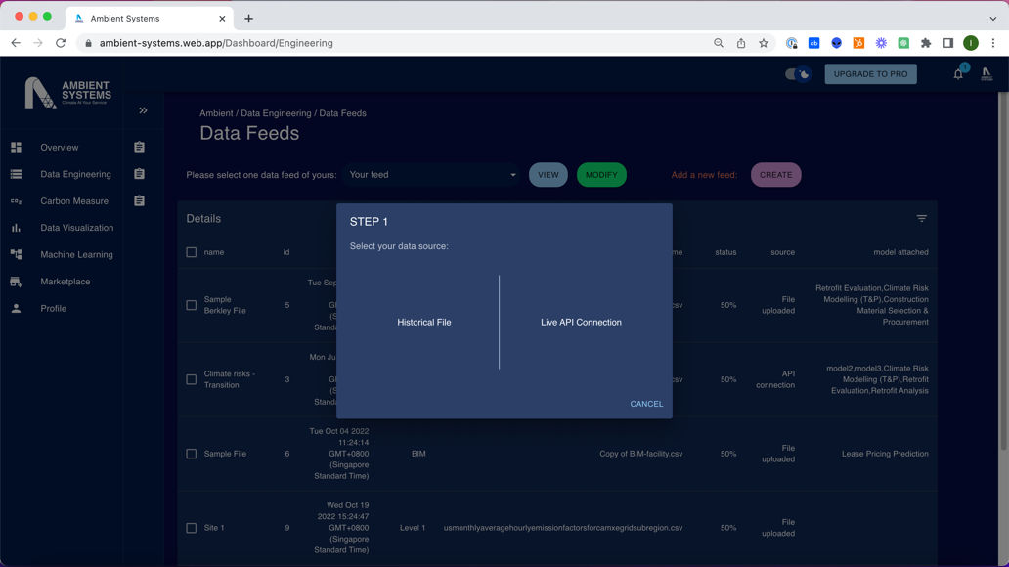
User Journey: Feature 1 – Combine Datasets
- Connect existing platforms.
- Connect traditional legacy databases without migration.

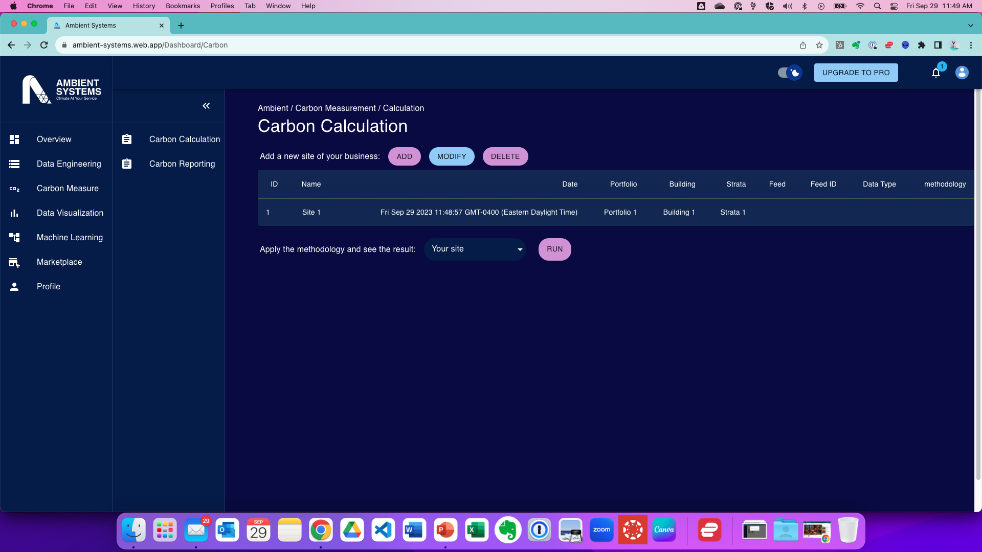
User Journey: Feature 2 – Automate Workflow
Key Features
- Metric Library
- Account Reconciliation
- Auto-calculate Financial Performance Metrics
- Compliance and Audit Reports
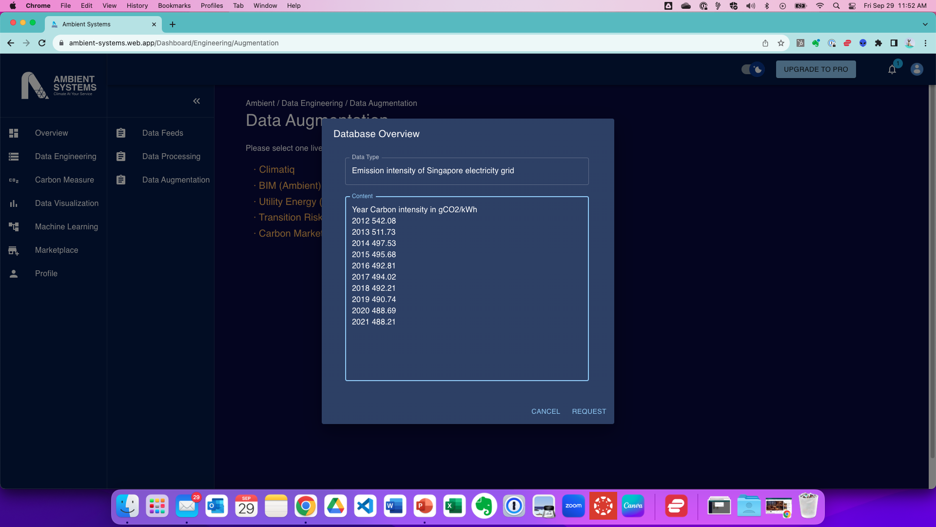
User Journey: Feature 3 – Add New Data
Key Features
- New/Niche/Proprietary Datasets
- Insightful Reports and Dashboards
- Data Visualizations
- Alerts and Notifications

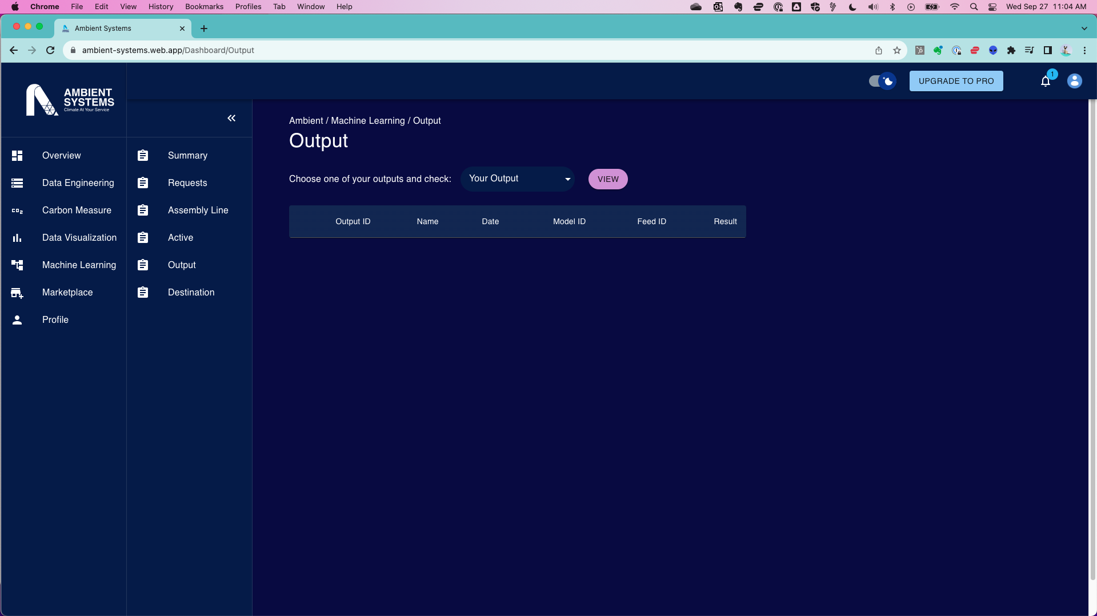
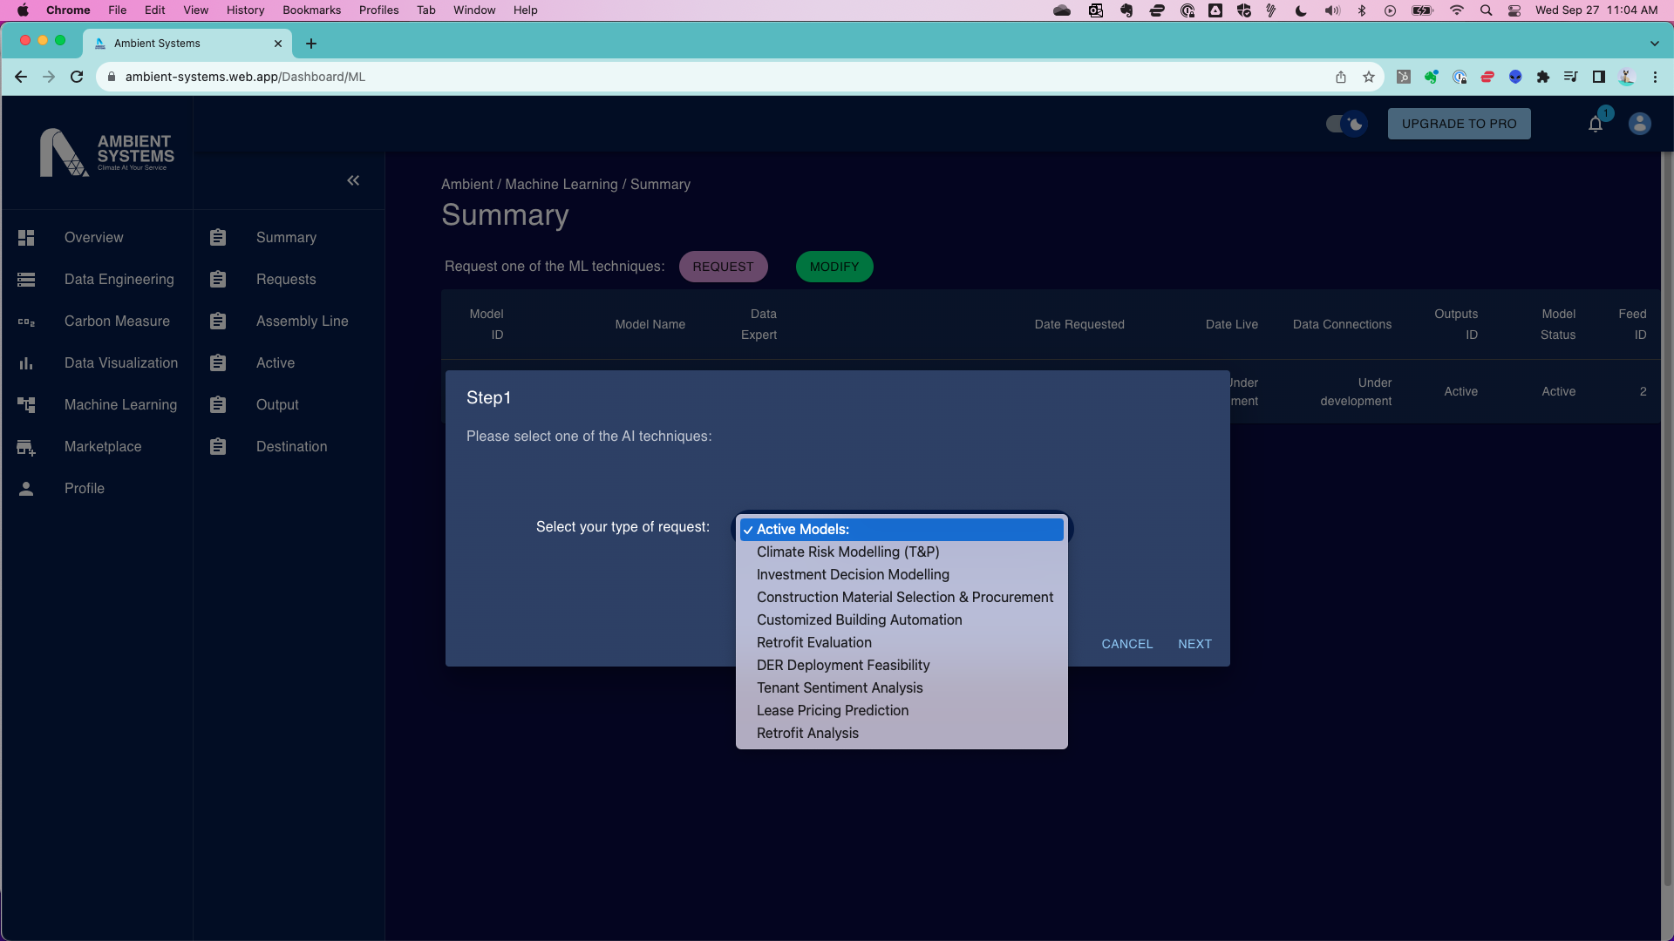
User Journey: Step 5 – Output
You will be given reports with the following outputs:
- Predictions/Forecasts
- Classification
- Recommendations
- NLP Outputs
- Image/Video Output: Object detection, facial recognition, image captioning
- Explanations/Interpretations
- …
User Journey: Feature 4 – Leverage ML and AI
Key Features
- Request model
- Select datasets.
- Assign data science expert

Appendix E: Tentative Customer List

Phase 1 (Year 1 to Year 3)
Segment | Industry Vertical | Location | Accounts | Leads
Hong Kong Commercial Real Estate | Commercial Real Estate | Hong Kong | 17 | 144
Hong Kong Transportation | Transportation | Hong Kong | 6 | 2
Hong Kong Financial Services, Insurance, & Investments Industry | Financial Services, Insurance, & Investments | Hong Kong | TBD | TBD
GBA | Commercial Real Estate | GBA | TBD | TBD
GBA | Transportation | GBA | TBD | TBD
Total Phase 1 |  |  | 23 | 146
Phase 2 (Year 4 to Year 6)
Segment | Industry Vertical | Location | Accounts | Leads
Japan Commercial Real Estate | Commercial Real Estate | Japan | TBD | TBD
Japan Transportation | Transportation | Japan | TBD | TBD
Singapore Commercial Real Estate | Commercial Real Estate | Singapore/Southeast Asia | 13 | 25
Singapore Transportation | Transportation | Singapore/Southeast Asia | 16 | 164
Singapore Vertical Farming | Vertical Farming | Singapore/Southeast Asia | 11 | 34
Korea Commercial Real Estate | Commercial Real Estate | Korea | TBD | TBD
Korea Transportation | Transportation | Korea | TBD | TBD
Total Phase 2 |  |  | 30 | 223
Phase 3 (Year 7 to Year 8)
Segment | Industry Vertical | Location | Accounts | Leads
 |  | Europe
 |  | US
 |  | UK
 |  | Canada
Total Phase 3

Appendix F: Competitive Landscape Analysis

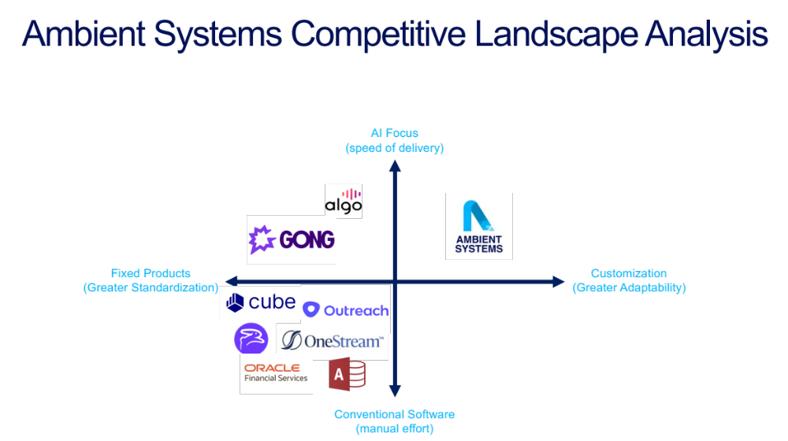

Ambient Systems:
- Fast: uses AI to increase speed to results.
- Adaptable: flexible and customizable with dedicated service & support.
- Straightforward: simplifies the user journey from goals to benefits.

X-Axis:
- This axis describes the focus of the company on adaptability vs standardization.
- This is measured in terms of formats and outputs that the platform can handle.

Y-Axis:
- This axis determines the extend that the product focuses on AI to speed up time to results.
- Ambient Systems uses AI in several stages of the solution:
  - AI import validation and verification.
  - Machine Learning for generating insights (industry-specific).
  - AI for any chat-bot interface applications similar to a conversational CFO.

Appendix G: Hiring Plan

Hiring Plan for Ambient Systems

Ambient Systems aims to strategically expand its workforce over the next three years to support the company's growth objectives and emerging opportunities in the financial technology sector. The hiring plan outlines key areas for recruitment, including roles, skills, and timelines.

Job Title: | Founder and R&D Lead
Job Type: | Full-Time | R&D Related
Responsibilities: | - Lead the R&D team in developing and launching the FP&M SW, ensuring it meets the needs of target users and market trends.  - Articulate a clear and compelling product vision for the FP&M SW, aligning it with user needs and industry expectations.  - Conduct user research and gather requirements to define the functional and non-functional requirements for the FP&M SW.  - Prioritize features and develop a product roadmap that outlines the development phases and feature rollout.  - Oversee the technology stack and ensure the FP&M SW is built on a robust and scalable infrastructure.  - Evaluate and adopt emerging technologies to enhance the FP&M SW's capabilities and maintain a competitive edge.  - Establish and implement data governance policies and procedures to ensure the security and privacy of user data.  - Protect the company's intellectual property through patents, copyrights, and other legal means.  - Collaborate with industry partners to gain insights, access resources, and validate the FP&M SW concept.  - Engage with potential and existing customers to gather feedback, identify new opportunities, and build relationships.
Requirements: | - Master's degree in Computer Science or a related field.  - Understanding of target industries and markets, including but not limited to transportation, construction, and commercial real estate  - Proven track record of success in leading and managing R&D projects in the science and technology fields.  - Expertise in emerging technologies, including cloud computing, artificial intelligence (AI), and the Internet of Things (IoT).  - Strong product vision and ability to translate market needs into innovative product solutions.  - Exceptional communication and collaboration skills to work effectively with a diverse team of engineers, data scientists, and product managers.  - Passion for technology and a commitment to driving innovation in the financial services industry.

Job Title: | Software Developer / Engineer (Full Stack)
Reports To: | Founder and R&D Lead
Job Type: | Full-Time | R&D Related
Responsibilities: | - Design, develop, and test core functionalities of the FP&M SW, including financial data management, reporting, and visualization tools.  - Contribute to the development of wireframes, prototypes, and mockups to test and refine user interfaces.  - Participate in user testing and feedback sessions to identify and address usability issues.  - Collaborate with data scientists and product managers to integrate machine learning algorithms for financial forecasting, risk assessment, and anomaly detection.  - Write clean, maintainable, and well-documented code, adhering to industry best practices and coding standards.  - Conduct thorough testing to identify and resolve bugs, ensuring the FP&M SW meets quality and performance expectations.  - Contribute to the development of the FP&M SW's architecture and infrastructure, ensuring scalability and maintainability.
Requirements & Qualifications | - Bachelor's degree in Computer Science, Software Engineering, or a related field.  - Proven experience in designing, developing, and testing software applications in the financial technology industry or a related domain.  - Strong proficiency in programming languages such as JavaScript, Python, or  - Familiarity with cloud computing platforms, including GCP or Azure.  - Experience with data structures and algorithms, including object-oriented programming principles.  - Excellent problem-solving and analytical skills, with the ability to identify and resolve complex technical issues.  - Strong attention to detail and a commitment to writing clean, maintainable code.  - Effective communication and collaboration skills to work effectively with a diverse team of engineers, scientists, and product managers.

Job Title: | Data Science Associate / Analyst
Job Type: | Full-Time | R&D Related
Responsibilities: | - Collaborate with software engineers to integrate machine learning algorithms into the FP&M SW, ensuring optimal performance and accuracy.  - Develop and implement machine learning models for financial forecasting, risk assessment, and anomaly detection, utilizing deep learning techniques and statistical methods.  - Analyze financial data to identify trends, patterns, and anomalies, providing insights to inform financial decision-making.  - Evaluate the effectiveness of machine learning models and refine them as needed to improve accuracy and performance.  - Stay up-to-date with emerging trends and advancements in machine learning and statistical techniques, exploring opportunities to incorporate them into the FP&M SW.  - Contribute to research initiatives aimed at enhancing the FP&M SW's capabilities and exploring new applications of machine learning in financial technology.
Requirements: | - Master's or PhD degree in Data Science, Mathematics, Statistics, or a related quantitative field.  - Proven experience in applying machine learning and statistical techniques to real-world financial data analysis and problem-solving.  - Expertise in programming languages such as Python, R, or MATLAB.  - Familiarity with machine learning frameworks such as TensorFlow, PyTorch, or scikit-learn.  - Strong statistical and mathematical foundations, including probability theory, hypothesis testing, and regression analysis.  - Excellent communication and collaboration skills to work effectively with a diverse team of engineers, scientists, and product managers.  - Passion for data-driven solutions and a commitment to using machine learning to enhance financial decision-making.

Job Title: | Sales Executive
Job Type: | Full-Time | Non- R&D Related
Responsibilities: | - Develop and execute sales strategies to achieve individual and team targets  - Identify and qualify potential leads through market research, networking, and cold calling  - Prepare and deliver sales presentations to potential clients  - Negotiate and close deals  - Build and maintain relationships with key decision-makers  - Track and analyze sales data  - Provide feedback to management on market trends and competitor activities
Requirements: | - Bachelor's degree in business, marketing, or a related field  - 3+ years of experience in sales  - Proven track record of success in achieving sales targets  - Excellent communication and presentation skills  - Strong understanding of our target market  - Ability to work independently and as part of a team  - Highly motivated and results-oriented

Job Title: | Marketing Manager
Job Type: | Part-Time | Non- R&D Related
Responsibilities: | - Develop and implement comprehensive marketing strategies aligned with business objectives  - Conduct market research to identify target audiences, trends, and opportunities  - Create and manage marketing budgets  - Develop and execute multi-channel marketing campaigns, including digital, social media, email, and print  - Manage and oversee the creation of marketing materials, such as website content, brochures, and social media graphics  - Track and analyze marketing campaign performance and make data-driven recommendations  - Manage and mentor a team of marketing professionals
Requirements: | - Bachelor's degree in marketing, communications, or a related field  - 5+ years of experience in marketing management  - Proven track record of developing and executing successful marketing campaigns  - Strong understanding of marketing theory and principles  - Excellent communication, presentation, and interpersonal skills  - Ability to work independently and as part of a team  - Highly motivated, creative, and results-oriented

